📘 Assignment: OSI Model & Network Protocols

🔹 Task 1: OSI Model with Example Protocols
Answer:
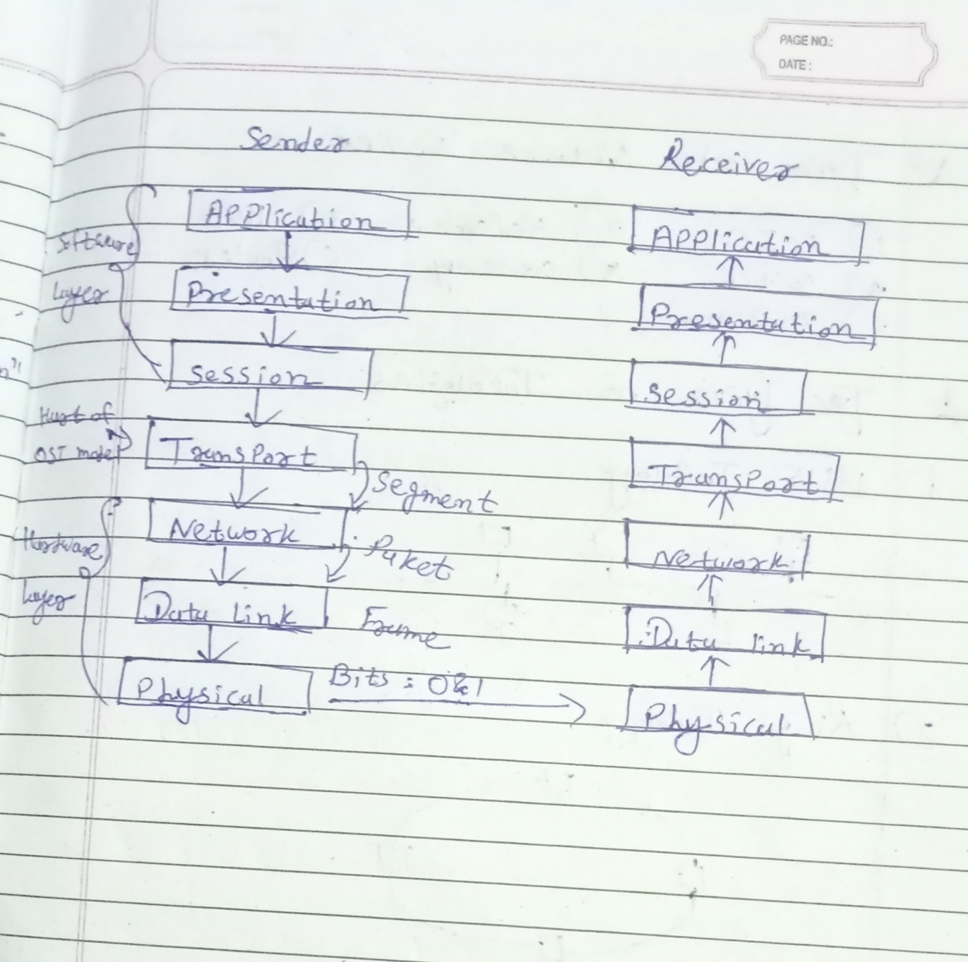

Task 2: Applications and Network Protocols
Application | Protocol 1 | Protocol 2
WhatsApp | HTTPS | TCP
Instagram | HTTPS | DNS
Zomato | HTTPS | TCP
Flipkart | HTTPS | DNS
Paytm | HTTPS | TCP

🔹 Task 3: Using ping and tracert
Windows Commands
ping www.youtube.com
tracert www.youtube.com
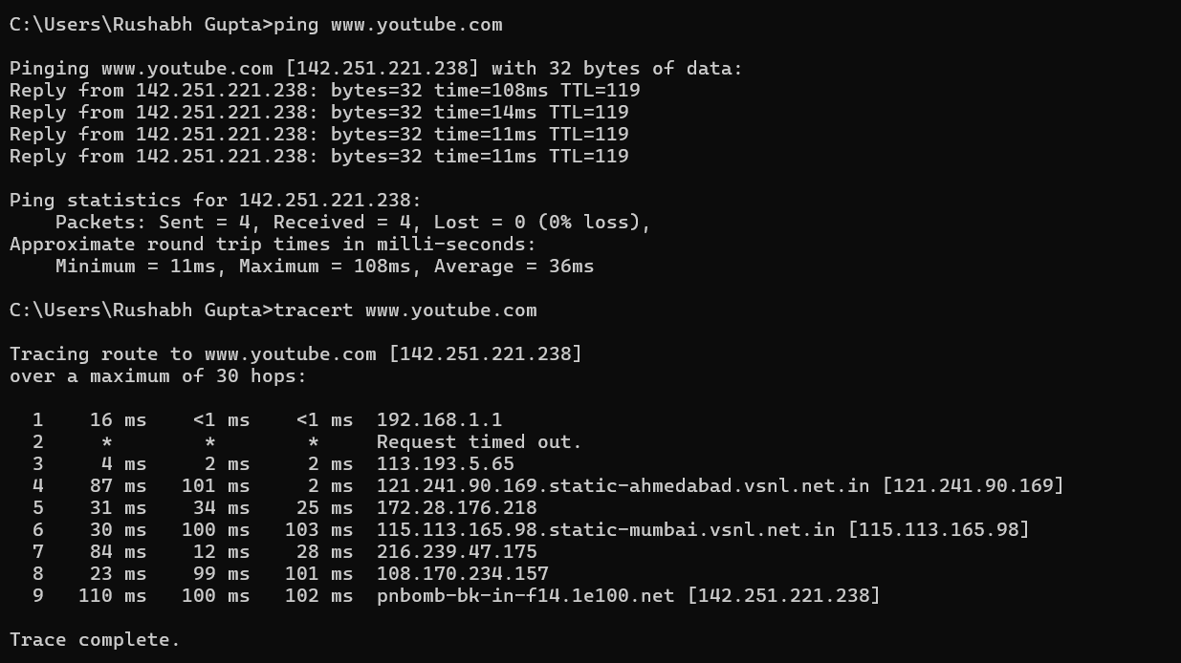
1. Ping Command
Command:
ping www.youtube.com
Result:
- Destination IP: 142.251.221.238
- Packets Sent: 4
- Packets Received: 4
- Packet Loss: 0%
- Average Time: 36 ms
Observation:
The ping command successfully reached YouTube's server, indicating that the network connection is working properly.

2. Tracert Command
Command:
tracert www.youtube.com
Result:
- Destination IP: 142.251.221.238
- Total Hops: 9
- Trace completed successfully.
Observation:
The tracert command displays the path (routers/hops) that packets travel from the local computer to YouTube's server. One hop timed out, which is common because some routers block ICMP responses.

OSI Layers Involved
OSI Layer | How it is involved in ping and tracert
Layer 1 – Physical Layer | Transmits electrical, radio, or optical signals over the network (Wi-Fi or Ethernet).
Layer 2 – Data Link Layer | Delivers data frames between devices on the local network using MAC addresses.
Layer 3 – Network Layer | Most important layer. Uses IP addresses and ICMP protocol to route packets between networks. Both ping and tracert operate primarily at this layer.
Layer 4 – Transport Layer | Not directly used because ping and tracert use ICMP, which operates over IP instead of TCP or UDP (Windows tracert specifically uses ICMP Echo Requests).
Layers 5–7 | Not involved because these commands do not establish sessions, present data, or interact with applications like web browsers.

How the Commands Work
Ping
- Uses the ICMP Echo Request and Echo Reply messages.
- Checks whether the destination host is reachable.
- Measures the Round-Trip Time (RTT) between the computer and the destination.
Tracert
- Uses ICMP Echo Requests with increasing TTL (Time To Live) values.
- Each router decreases the TTL by one.
- When TTL reaches zero, the router returns an ICMP Time Exceeded message.
- This reveals each router (hop) along the path until the destination is reached.

Task 4: WhatsApp Message Through the OSI Model
Scenario: Sending a message from your phone to a friend's phone using WhatsApp.
OSI Layer | What Happens
Layer 7 – Application | You type a message in WhatsApp and press Send.
Layer 6 – Presentation | The message is encrypted so that only the sender and receiver can read it.
Layer 5 – Session | A communication session between your device and WhatsApp's servers is maintained.
Layer 4 – Transport | TCP divides the message into smaller segments and ensures reliable delivery.
Layer 3 – Network | IP assigns source and destination IP addresses and determines the best route through the internet.
Layer 2 – Data Link | The message is converted into data frames with MAC addresses for transmission across the local network.
Layer 1 – Physical | The data is transmitted as electrical signals, radio waves (Wi-Fi), or mobile network signals.

